CREATING ADMINISTRATIVE UNITS

STEP-01 SIGN INTO AZURE PORTAL AND GO TO YOUR AZURE ACTIVE DIRECTORY AND SELECT ADMINISTRATIVE UNITS FROM THE LEFT PANE

STEP-02 SELECT THE +ADD OPTION

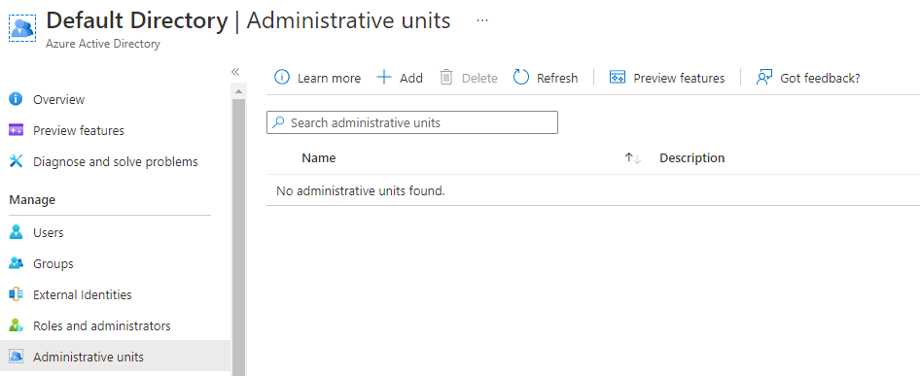

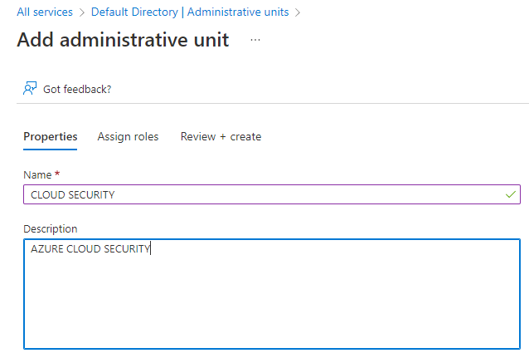

STEP-03 SELECT YOUR ROLES AND THE USERS THE ROLE IS GOING TO BE ASSIGNED TO.

AS SHOWN BELOW, I AM USING DEFAULT ROLES. I SELECTED THE HELPDESK ADMINSTRATOR ROLE AND SINCE I ONLY HAVE ONE USER TO CHOOSE FROM AT THIS MOMENT I AM SELECTING MY NC GHOST USER TO BE ADDED TO HELPDESK ADMINISTRATOR ROLE.

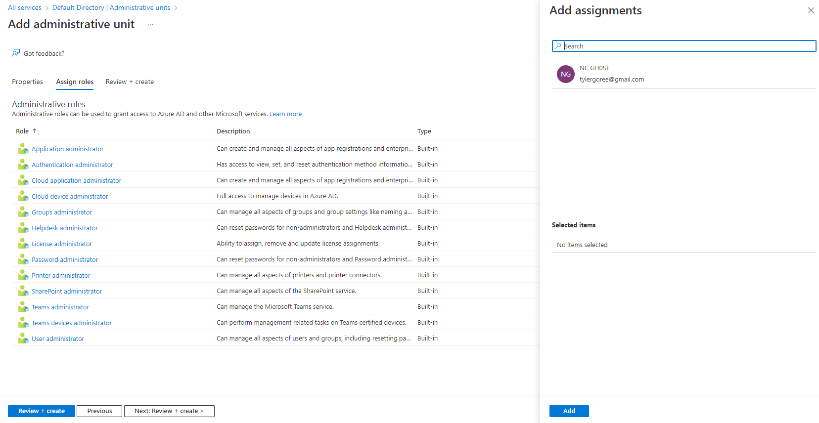

STEP-04 REVIEW AND CREATE

FOR MORE INFROMATION CHECK OUT: [Create or delete administrative units - Azure Active Directory - Microsoft Entra | Microsoft Docs](https://docs.microsoft.com/en-us/azure/active-directory/roles/admin-units-manage)